Testing Document – Matthew Stewart – B01032816
Test Cases
To start off with the testing document after finishing with implementation of the development and design choices along with any programming included in the Zoo Management System. I have created table which hosts all the test cases that I have designed for the System. Most of theses test cases includes normal functionality of the test case along with some boundaries and errors to properly test the systems limitations. In hope to meet the requirements set forth in the system. Such test cases including adding and new animal to printing the report to see how many animals or if an error appears. This allows us to go back after testing to fix theses issues, ensuring whenever we launch the Zoo Management System for the Zoo that no errors arise. Now looking back at the test cases, we can see that almost of them have passed with flying colours. Which is since before I did test, I looked through the code and adding a bunch of try-catch to handle and deal with errors. However, I didn’t manage to catch all of them, as you can see that there are a couple of test cases that did not pass.

Test case NO | Test case description | Test Data | Expected Results | Actual results | Status (Pass/Fail)
TC-01 | Add new Animal  (Normal) | Animal: Shark, Name: Spike1, Age: 0, Weight: 60, Jaw Strength:1 | Animal successfully added | 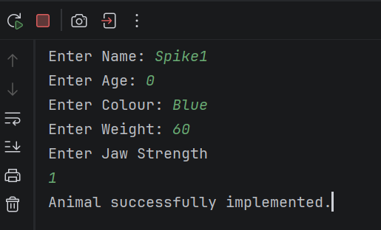  The animal has successfully been added as it states after inputting new animal information. | PASS
TC-02 | Add new Animal  (Error) | Animal: Owl, Name: Hoot, Age: Unknown, Weight: 22, Grip strength:3 | Error as Age must be an Integer value | 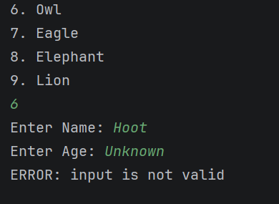  After trying to input the age of the new owl animal. An error pops up saying the input is valid and breaks the switch case. Rejecting the Animal. | PASS
TC-03 | Add new Animal (Boundary) | Animal: Lion, Name: Ryan, Age: 0, Colour: Orange, Weight: 40,  Mane Size: 5 | The animal should still be added to the Zoo | 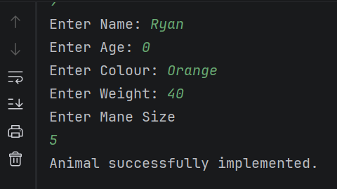  Although zero is typed for the age, no errors occur and the Animal is successfully implemented into the zoo. | PASS
TC-04 | Remove Animal (Normal) | Animal: Monkey, Name: George | Animal should be successfully removed. | 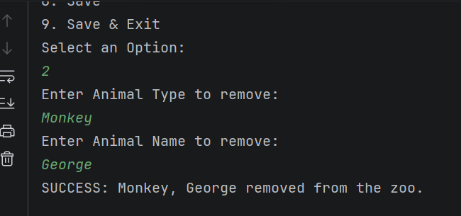  The monkey George is successfully removed from the Zoo however it will not update until saved. | PASS  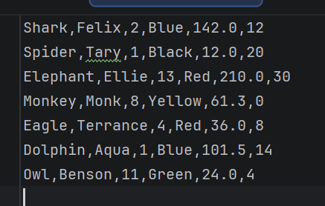
TC-05 | Remove Animal with no animals in zoo  (Error) | Animal: Monkey, Name: George | An error should occur. | 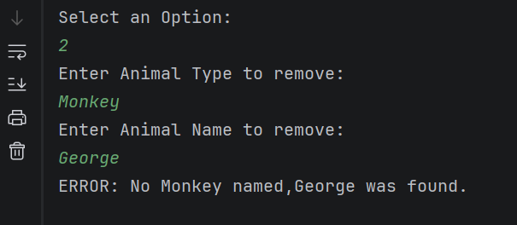  While trying to remove George again from the system causes an error to occur in the system, saying that no named monkey called George was found. | PASS
TC-06 | Remove Animal (Boundary) | Animal: Lion, Name: Ryan | On printReport, the ArrayList should have a size of 0 | 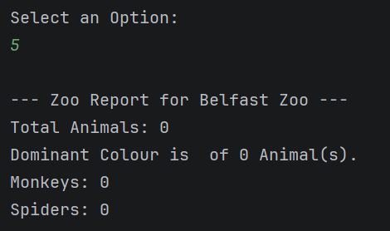  Removing the only animal being Ryan the Lion, after saving and checking the report we can successfully see that there is a total of 0 animals now in the zoo management System | PASS
TC-07 | Modify Animal (Normal) | Name: Aqua, Detail changing: Weight, New weight value:120 | Animal Info Updated | 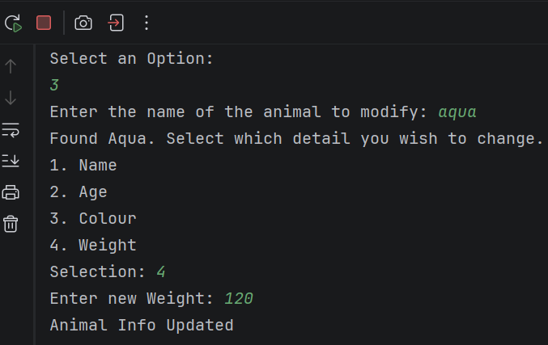  After typing in the new weight for aqua, we get a signal saying that the Animal Aquas information has been updated. | PASS
TC-08 | Modify Animal (Normal) | Name: Monk, Detail changing: Weight, New weight value:64 | Animal Info Updated | 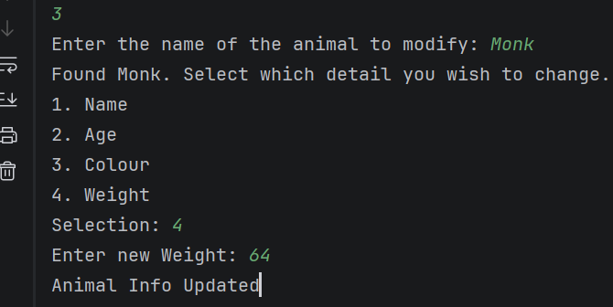  By trying a different animal. This type being Monk, we change his weight as well but with trying different animals it allows us to make sure that we are getting the data properly from each of the animals, along with updating the data properly as well. | PASS
TC-09 | Modify Animal (Error) | Name: Tary, Detail changing: Weight, New weight value:13+ | Error as Weight must be an integer value | 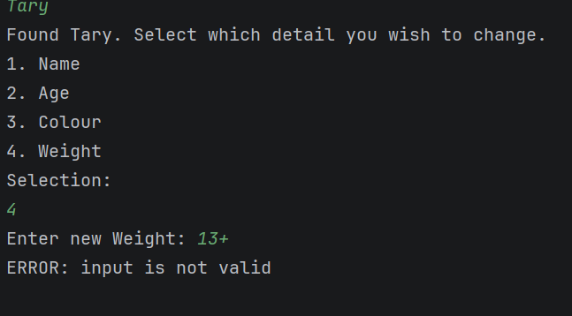  For this error test case we are checking to see if a non-integer would cause problems with the method in which it did. It caught the error and then an error popped up for the user to read: stating the input is invalid | PASS
TC-10 | View All Animals (Normal) | Request to view all animals | All animal information displayed | 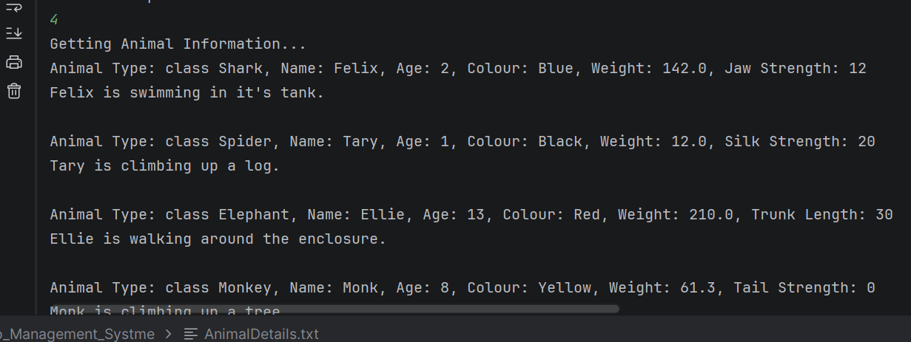  This test case has passed as you can see it is currently printed out all of the animals that is currently within the zoo. | PASS
TC-11 | View All Animals (Boundary) | Empty animal details | It should display that the zoo is empty. | 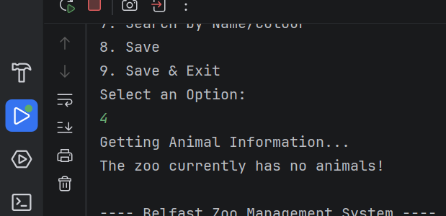  This is a boundary checking, checking to see if it still runs even if there are no animals, which it does however it explicitly states that there are no animals within the zoo. | PASS
TC-12 | View All Animal (Boundary) | Having only one animal | Should show the singular animal information | 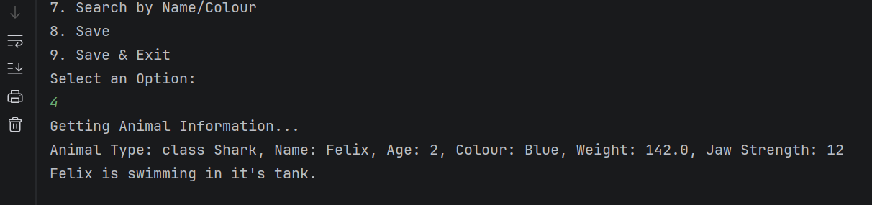  This is a boundary check which prints out only one animal. This being the only animal in the zoo. Passing the singular boundary check. | PASS
TC-13 | Print Report (Normal) | Request to print Zoo report | Zoo report printed | 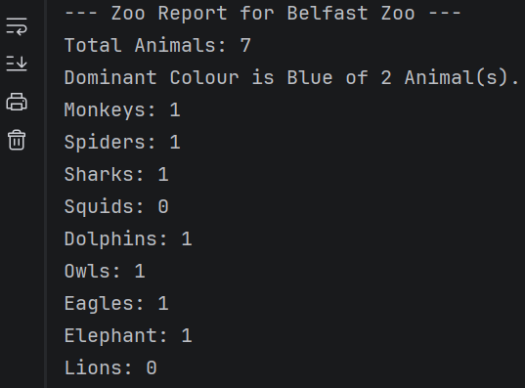  One triggered the report is triggered perfectly showing how many animals are in the zoo, as well as the most favourited eye colour. And individual species count. | PASS
TC-14 | Print Report (Error) | Print the Report whenever no Animals are in the zoo | Report prints and shows zero animals, no favourite colour | 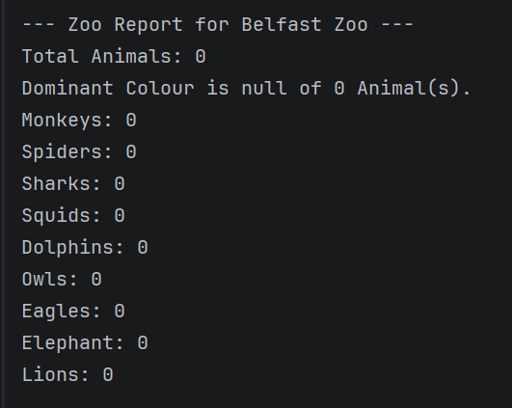  This is an error check to see if any issues would arise from having no animals in the zoo and printing the report. However, it works even without animals to include. | PASS
TC-15 | Print Report (Error) | Testing to see if an error shows whenever there’s an undefined animal type: Leopard | Error should throw stating that there is an animal type not defined in the zoo | 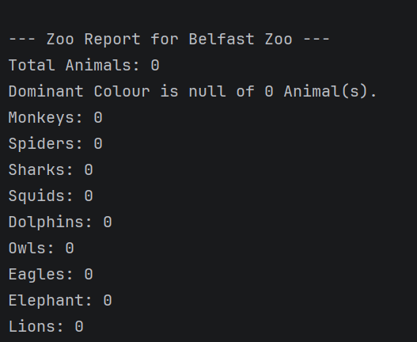  This is a fail as it doesn’t check to see if the undefined animal type. There is not error that appears to indicate it either. | FAIL
TC-16 | Perform Daily Care (Normal) | Request to perform daily care: Option 6 | Zookeeper to commence care checks and full details displayed | 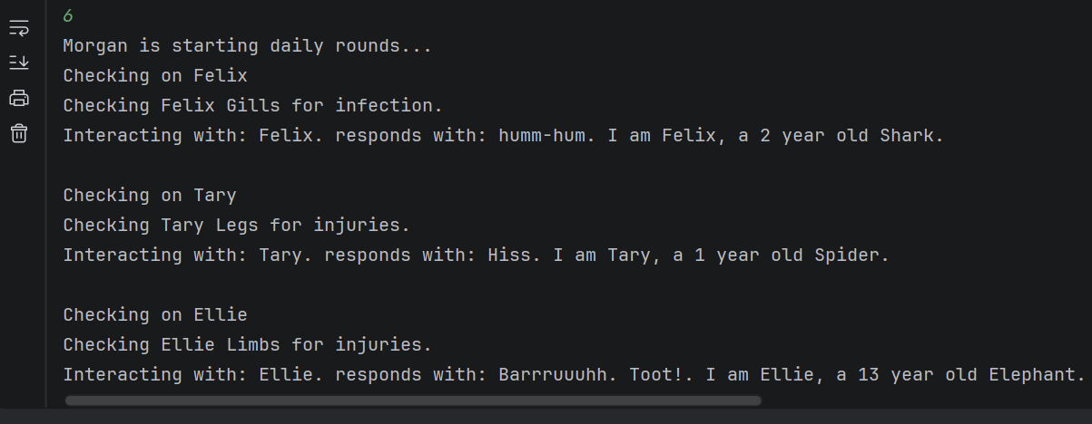  When triggered the zookeeper calls each animal class make sound method along with their checkup methods. Leaving a buffer for readability. | PASS
TC-17 | Perform Daily Care (Boundary) | Request to perform daily care: Option 6 | Should say that there are no animals for the zookeeper to care for. | 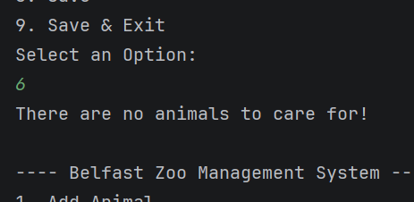  This is a boundary check in which we have no animals within the zoo. As we trigger daily care method in main it checks to see if there are any animals to care for. Which there is not so it returns with that output. | PASS
TC-18 | Perform Daily Care (Boundary) | Request to perform daily care: Option 6 with over 100 animals to care for. | Should successfully care for each of the animals without skipping or crashing. | 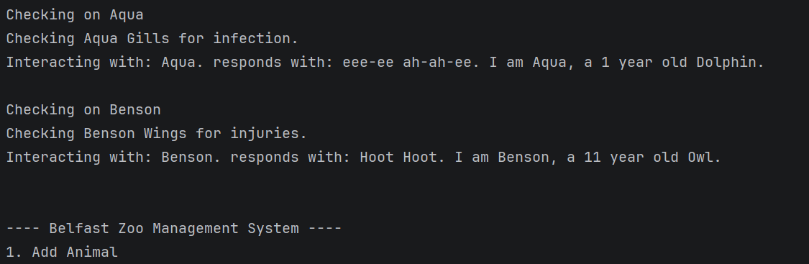  This is another boundary check. This time with 100 animals. It goes through each of the animals without skipping or crashing. | PASS
TC-19 | Search for Animal (Normal) | Search for name: Ellie | Search for name: Ellie  Animals’ information displayed | 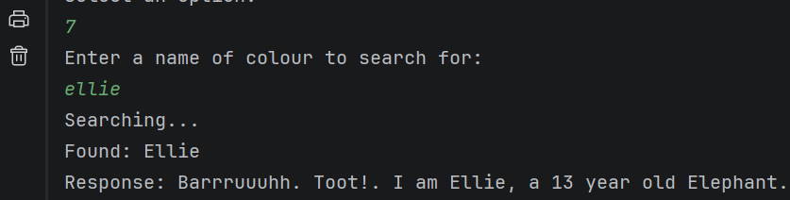  When triggered it searches for the animal ellie by name. Stating when the animal is found and then it makes a sound. | PASS
TC-20 | Search for Animal (Boundary) checking for case sensitivity | Search for MONK. | MONK should still work and it should bring up monks the monkey details | 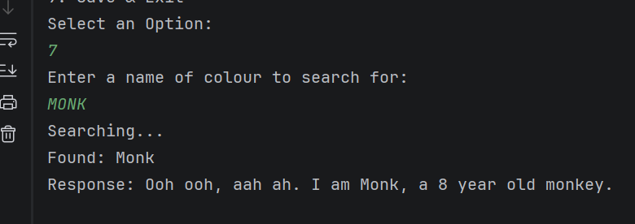  This boundary check is checking if the code Is case sensitive. In which it is not as it still passes. Finding Monk and playing its sound. | PASS
TC-21 | Search for Animal (Error) | Search for name: @;’” (space after name) | Error as name should only be a string - no other characters expected | 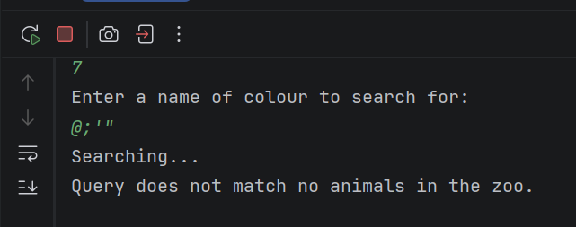  This is another fail test case as we input String for the code to hopefully throw an error as there is no animal or use proper characters. However, it doesn’t and still tries to look for the animal which doesn’t exist. | FAIL
TC-22 | Save Data (Normal) | Request to save data | Data saved to disk | 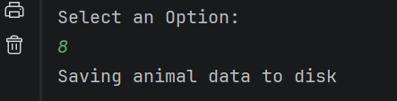  The data is saved as this is outputting onto the terminal once we hit the save button on the menu | PASS
TC-23 | Save and Exit (Normal) | Request to save and exit | Data saved and system exited | 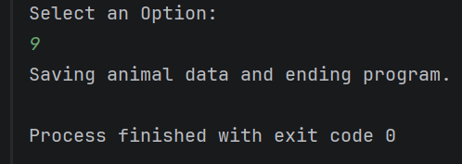  This occurs whenever we hit the save and exit button, still saving the animals to the txt file however it also ends the program. | PASS
TC-24 | Save Data (Boundary) | Saving while having zero animals in zoo | System should still save without errors, creating new file if required | 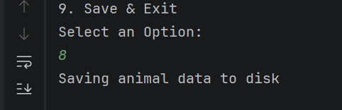  Even though there are no animals currently in the zoo, it saves flawlessly without any errors rising. | PASS
TC-25 | Menu Interaction (Normal) | Inputting 4 to view all animals | It should print all the animal details | 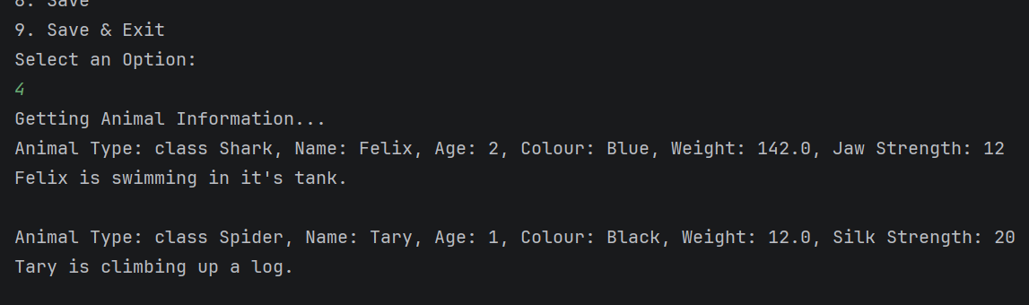  After hitting 4 in the main menu It does print all animal details. Allowing the test case to pass. | PASS
TC-26 | Menu Interaction (Error) | Inputting 10 | It should say that it is an invalid option | 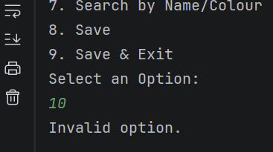  With this error. Being us inputting 10, being an option that doesn’t exist. It successfully outputs an error message saying, “Invalid option.”, telling the user it is invalid before running the while loop again. | PASS
TC-27 | Menu Interaction (Error) | Input “Lion” | Should say that input is not valid | 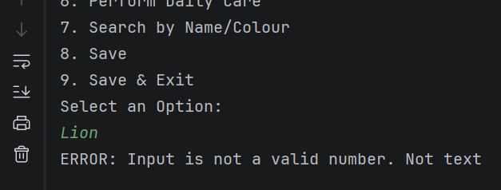  Inputting text into the menu which only accepts integers has causes an error message to arise. Stating that the input cannot be an invalid number or text. | PASS
TC-28 | Menu Interaction (Boundary) | Empty Input | Should say to input a valid number | 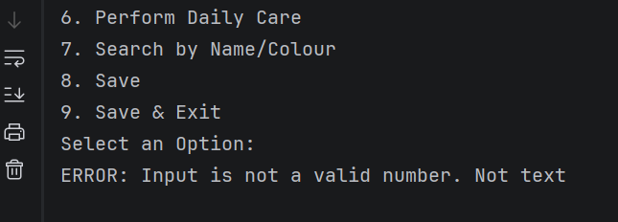  With this boundary check. It also checks If the input has been left empty and if it has. Then it will again run the same error as it is not a number. | PASS
TC-29 | Pre-load zoo data | Start program | Data should say that data has been loaded from disk | 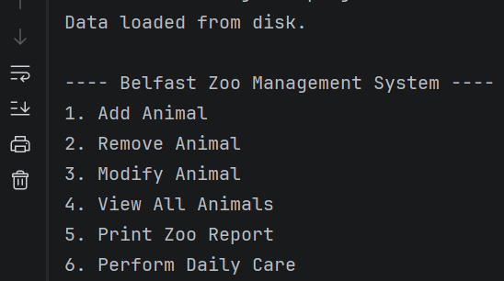  Finally with Pre-load Zoo data. It occurs whenever we start the program. We can see this is a pass as at the top or the first thing that Is outputted on the terminal is that the data is loaded. | PASS

Unit Test
Along with test casing I have also did two pieces of unit testing that I have coded and implemented. This is useful as it allows us to isolate pieces of code, basically giving it a trial to see if it functions as intended or if it will need to be worked on further. Such two pieces unit testing includes a validation test and a sound test, for the likes of the sound test firstly it was created to pre-test the makeSound() method which would be used in the animal class. While the validation test checks to see if the monkeys name is valid using the IsValid() method in the animal class.
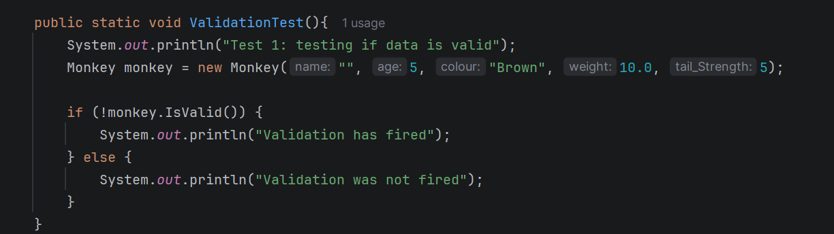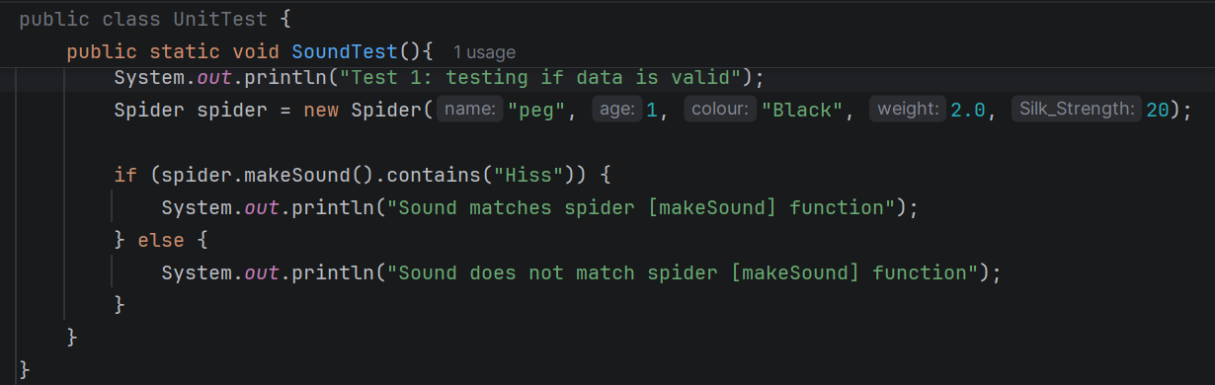
For the likes of the two-unit tests. The expected result for the validation test with the monkey not having a name is the validation should fire, since the if statement has (!monkey.IsValid()) meaning it is specifically checking that the monkey is not valid. Causing the validation to fire. Proving as a successful unit test.
While the other unit testing being the Sound test. Is testing if the test animal is making a specific sound. It does this by specifically asking if the spider makeSound() contains a specific test. This being “Hiss” in which it does so the system will print out that the Sound matches. Proving as another successful unit test. Sadly, with the likes of the SoundTest() unit test It was fully implemented in which it checks, nor does it truly show polymorphism with method overriding.
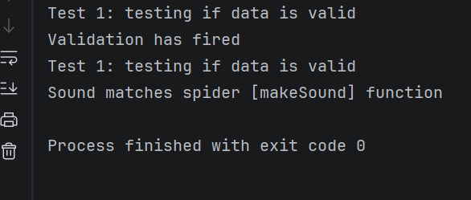
Summary Requirements
Finally with the summary requirements which is used to outline the implementation of each requirement for the Zoo Management System. I have tried my best to include every single requirement into the System which I have successfully done, and to a high standard with the use of test cases to ensure that no errors arise in the future for the Zoo System. Sadly, I could not add any additional features as I thought that it wasn’t really required. The system functionality didn’t need additional content as it could possibly slow it down and Effective system performance.
Requirements | Implemented | Test case ID designed
Ability to pre-populate the application with any previously stored data | Yes | TC-29
Ability to add an animal | Yes | TC-01, TC-02, TC-03
Ability to remove an animal | Yes | TC-04, TC-05, TC-06
Ability to modify an animal | Yes | TC-07, TC-08, TC-09
Ability to search for an animal | Yes | TC-19, TC-20, TC-21
Ability to do dailycare on animals | Yes | TC-16, TC-17, TC-18
Ability to print a report | Yes | TC-13, TC-14, TC-15
Be command line-based interactions | Yes | TC-25, TC-26, TC-27, TC-28
Ability to view all animals currently in zoo | Yes | TC-10, TC-11, TC-12
Ability to save and update existing animal details | Yes | TC-22, TC-23, TC-24
Implementation of additional features | No | N/A

